Name - Amit Kumar
Course - HPC

Day 1: Question bank
Q.No. | Correct Answer
1 | B – A device that processes data into information
2 | B – A set of instructions for the computer
3 | B – To communicate with other humans
4 | B – C
5 | B – The rules for writing code in a language
6 | B – A step-by-step procedure to solve a problem
7 | C – Machine language
8 | B – Written using mnemonics
9 | B – Assembler
10 | A – Compiler
11 | B – Interpreter
12 | D – Executes faster than machine language
13 | C – Binary codes (0s and 1s)
14 | B – HTML
15 | C – To convert human-readable code into machine-readable form
16 | B – They generate a separate executable file
17 | B – Python
18 | C – Syntax error
19 | C – %d
20 | D – total marks
Lab Assignment: Practical C Programming

1. Create a program to declare two integer variables, assign them values, and display their values
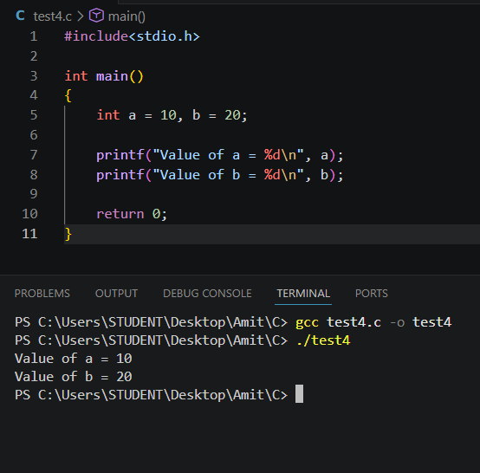

2. Create a program to input the name of the person and respond with ”Welcome NAME to C Programming”.
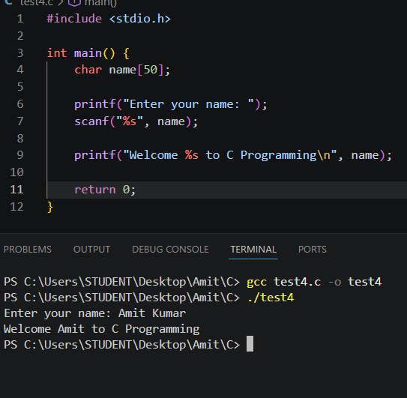

3. Define variables for storing a user's first name, last name, and age using appropriate naming conventions and then display them.
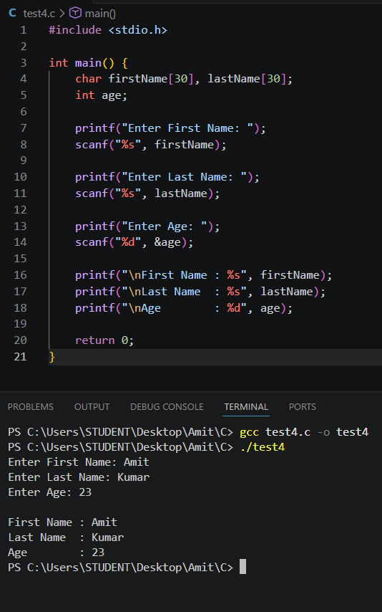
4. Create a program to print the area of a square by inputting its side length.
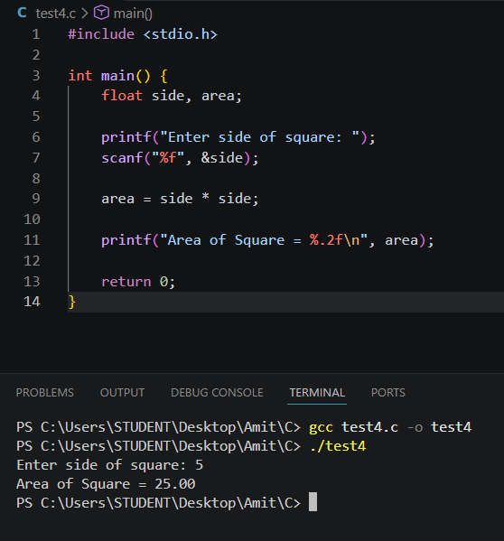

5. Create a program to define a constant for the mathematical value pi (3.14159) and use it to calculate and print the circumference of a circle with a radius input from the user.
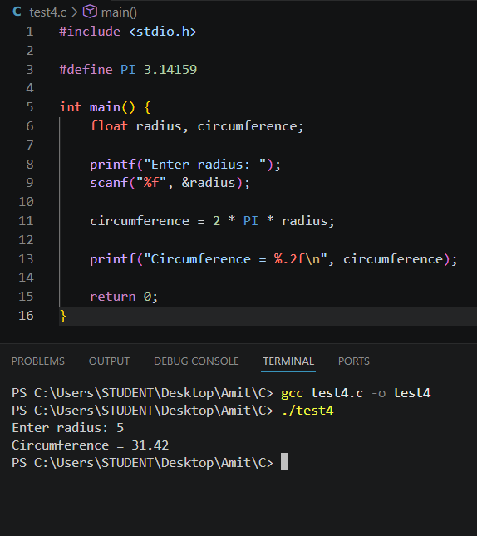

6. Create a program to print the area of a circle by inputting its radius.
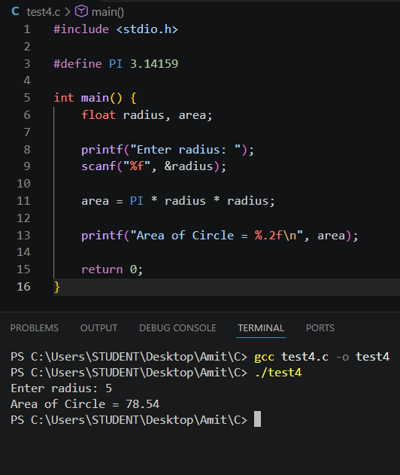

7. Create a program to swap two numbers.
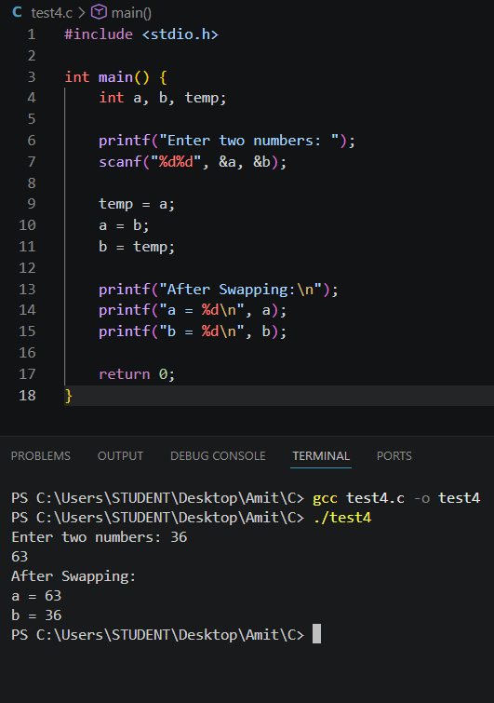

8. Write a C program that asks the user to input two integers, then performs and displays the results of the following arithmetic operations: Addition Subtraction Multiplication Division (show the result as a float) Modulus (remainder) Make sure the program properly handles integer inputs and prints the results clearly. 📋 Sample Output: Enter two integers: 10 3 Results: Addition = 13 Subtraction = 7 Multiplication = 30 Division = 3.33 Modulus = 1
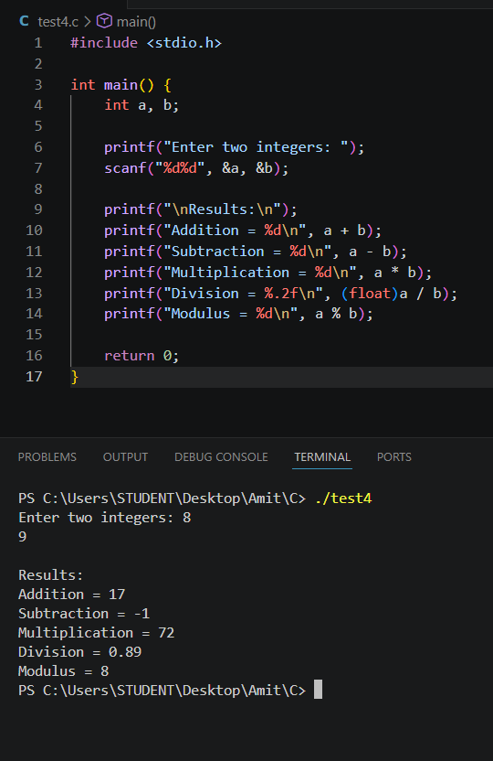
9. Write a program to calculate Simple Interest using the formula interest = (principal * rate * time) / 100
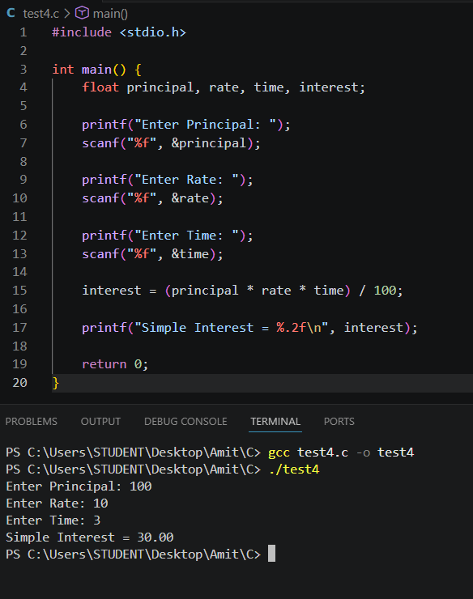

10. Write a program to add, subtract, multiply, and divide two numbers.
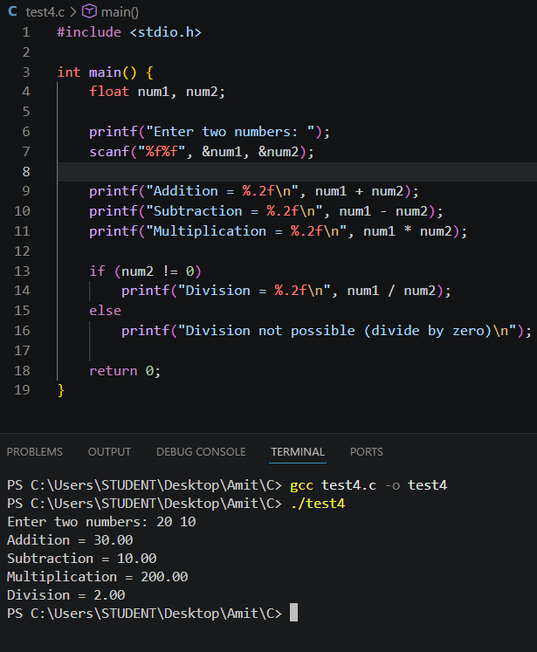

11. Write a program to calculate Compound Interest. amount = p * pow((1 + r / 100), t) ci = amount - p; Hint: Use #include
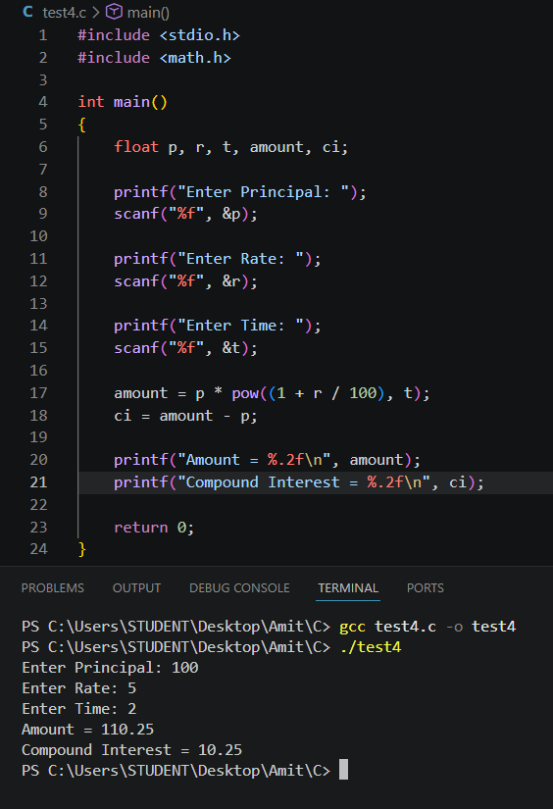
12. Write a program to calculate BMI (Body Mass Index).
bmi = weight / (height * height)
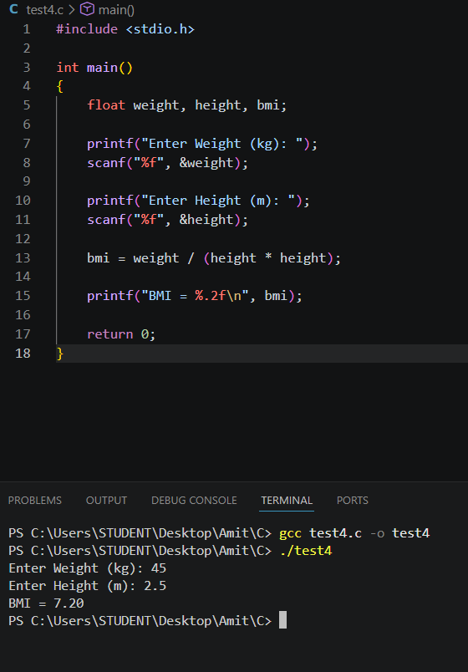
13. Write a program to convert Celsius to Fahrenheit. f = (c * 9 / 5) + 32
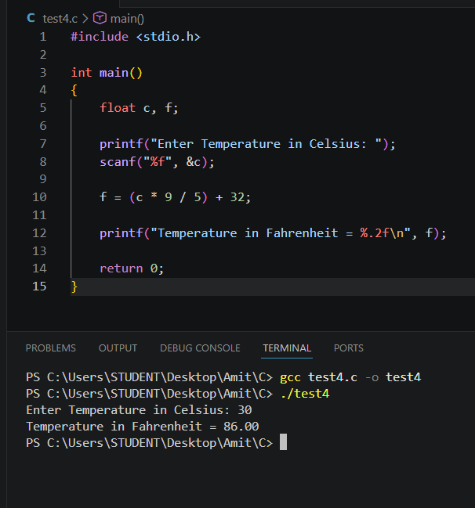

14. Write a program to convert Fahrenheit to Celsius. c = (f - 32) * 5 / 9
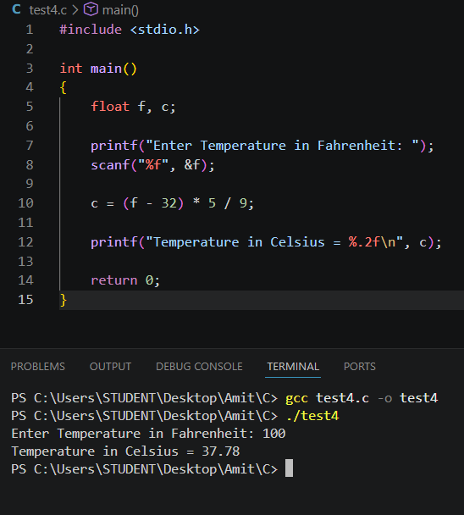

15. Write a program to calculate the percentage of marks (5 subjects, out of 100 each). total = m1 + m2 + m3 + m4 + m5 percentage = total / 5
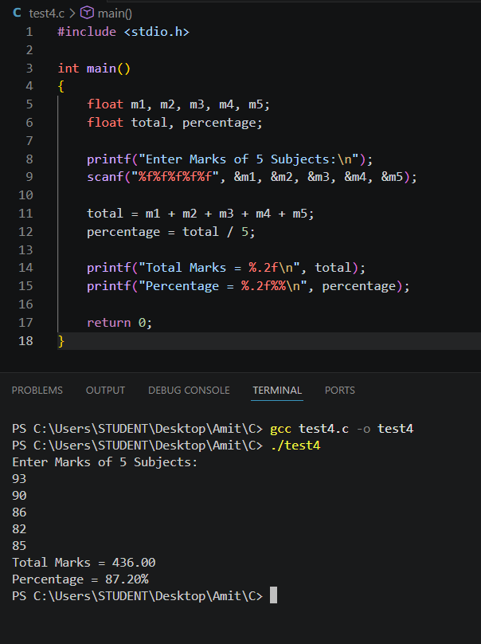
16. Write a program to calculate the discounted price of an item. discount = (price * discountPercent) / 100 finalPrice = price - discount
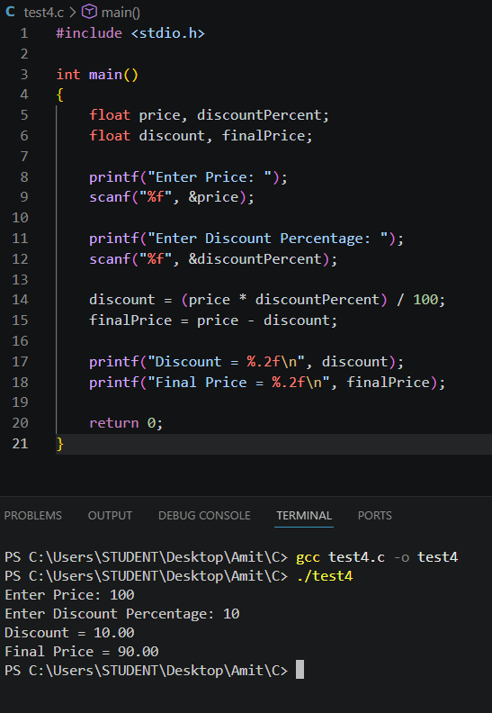
17. Write a program to calculate speed, given distance and time. speed = distance / time
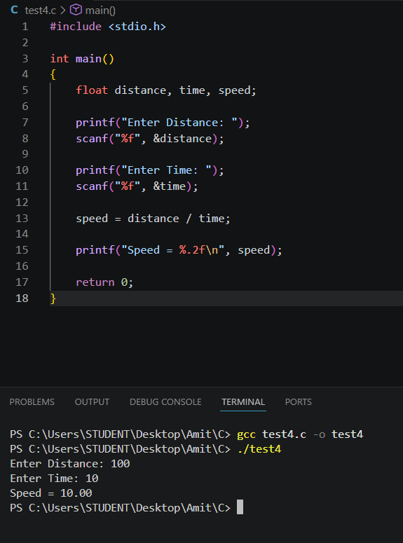
18. Write a program to calculate net salary = (basic pay + allowance − deductions).
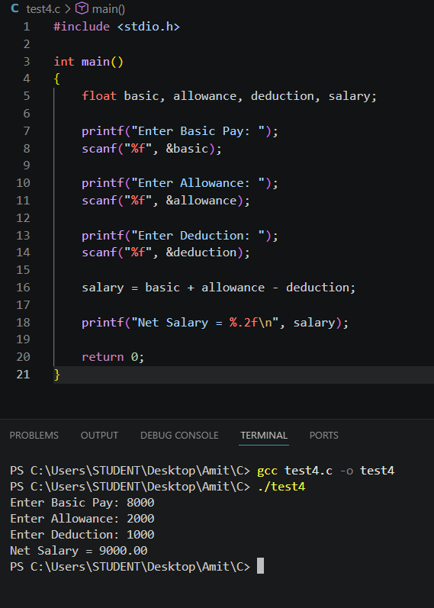
19. Predict the output and verify it by running the program. #include int main() { int x = 5; printf("x = %d\n", x); printf("x++ = %d\n", x++); printf("After x++ = %d\n", x); printf("++x = %d\n", ++x); printf("Final x = %d\n", x); return 0; }
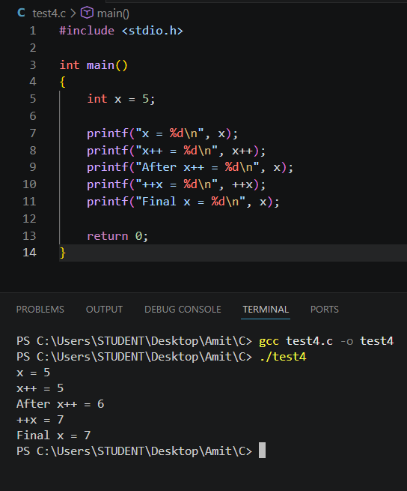

20. Predict the output and verify it by running the program. #include int main() { int i = 6, j = 3, k; k = ++i * j--; printf("i = %d\n", i); printf("j = %d\n", j); printf("k = %d\n", k); return 0; }
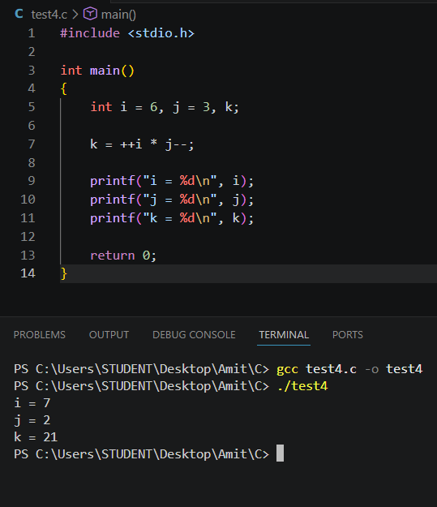

Explain:

1. Why is C called a mid-level programming language?
C is called a mid-level programming language because it combines the features of both low-level and high-level languages.
Supports low-level programming using pointers and direct memory access.
Supports high-level programming using functions, loops, and structures.
Used for both system software and application software.

2. What are the features of the C programming language?
Features of C:
Simple and easy to learn
Portable (runs on different platforms)
Fast execution
Structured programming
Rich library functions
Supports pointers
Dynamic memory allocation
Modular programming using functions

3. Explain the internal execution of a program to swap two numbers.
Steps:
Declare two variables (a and b) and a temporary variable (temp).
Store the value of a in temp.
Copy the value of b into a.
Copy the value of temp into b.
Print the swapped values.
Example:
Before:
a = 10
b = 20

After:
a = 20
b = 10

4. When is your program ready to execute?
A C program is ready to execute when:
The source code has no syntax errors.
It is successfully compiled.
The linker creates an executable file (.exe in Windows).

5. Explain the compilation process in C.
The compilation process consists of four stages:
Preprocessing – Processes directives like #include and #define.
Compilation – Converts C code into assembly code.
Assembly – Converts assembly code into object code.
Linking – Combines object code with library files to create the executable program.

6. Difference between Compiler and Interpreter
Compiler | Interpreter
Translates the whole program at once | Translates one line at a time
Produces an executable file | Does not produce an executable file
Faster execution | Slower execution
Errors shown after compilation | Errors shown line by line
Example: GCC | Example: Python Interpreter

7. What is the purpose of #include <stdio.h> in a C program?
#include <stdio.h> includes the Standard Input/Output Header File.
It provides declarations for functions such as:
- printf()
- scanf()
Without this header, these functions cannot be used properly.

8. Explain the difference between printf() and scanf() with examples.

printf() : Used to display output on the screen.
Example:
printf("Hello World");

scanf() : Used to take input from the user.
Example:
int age;
scanf("%d", &age);

printf() | scanf()
Output function | Input function
Displays data | Reads data
No & needed | & is required for variables (except character arrays)

9. What are format specifiers in C? Explain any five.
Format specifiers tell printf() and scanf() what type of data is being used.
Specifier | Data Type | Example
%d | Integer | int a = 10;
%f | Float | float x = 3.5;
%c | Character | char ch = 'A';
%s | String | char name[] = "Amit";
%lf | Double | double d = 12.45;

10. Explain the difference between pre-increment (++i) and post-increment (i++) with an example.

Pre-increment (++i) :The value is incremented before it is used.
Example:
int i = 5;
printf("%d", ++i);
Output:6

Post-increment (i++): The current value is used first, then it is incremented.
Example:
int i = 5;
printf("%d", i++);
Output:5
After execution:
i = 6

11. Why do we use the main() function in every C program?
The main() function is the entry point of a C program.
When a C program starts executing, the operating system calls the main() function first.

12. What is the purpose of the return 0; statement?
return 0; is used to indicate that the main() function has completed successfully.
return 0; indicates successful completion of the C program.

13. Why do we use the address operator (&) in scanf()?
The address operator & gives the memory address of a variable.
scanf() needs the address of the variable so that it can store the user's input directly into that memory location.
Example:
int age;

scanf("%d", &age);
Here: &age means the address of age.
The value entered by the user is stored at that address.

Important:
Correct:
scanf("%d", &age);
Usually incorrect for a normal integer variable:
scanf("%d", age);
In simple words: & tells scanf() where to store the input value.

14. What is the difference between float and double?
Both float and double are used to store decimal/floating-point numbers.
Feature | float | double
Typical size | 4 bytes | 8 bytes
Precision | Lower | Higher
Approx. precision | 6–7 digits | 15–16 digits
Memory | Less | More
Example | 3.14f | 3.1415926535
Use float when normal precision is sufficient and double when higher precision is required.

15. Explain the difference between unary operators and arithmetic operators with examples.

Unary Operators : A unary operator works on only one operand.
Examples: ++i, --i, -i

Arithmetic Operators: Arithmetic operators are used to perform mathematical operations.
Common arithmetic operators are:
+ Addition
- Subtraction
* Multiplication
/ Division
% Modulus

Difference:
Unary Operator | Arithmetic Operator
Works on one operand | Usually works on two operands
++, --, unary - | +, -, *, /, %
Example: ++a | Example: a + b

16. What is a variable in C? Explain the rules for naming (identifiers) a variable with examples.
A variable is a named memory location used to store data whose value can change during program execution.
Example: int age = 24;
Here:
- int → data type
- age → variable name
- 24 → value

Rules for naming variables
- Name can contain letters, digits and underscore.
- Name cannot start with a digit.
- Spaces are not allowed.
- C keywords cannot be used as variable names.
- C is case-sensitive.
- Special characters such as @, #, $ are not allowed.

Valid identifiers:
age
student_name
marks1
_total

Invalid identifiers:
1student // starts with digit
student name // contains space
float // keyword
student@name // special character
Example:
int student_age = 20;

17. What are literals in C? Differentiate between constants and literals with examples.

Literal : A literal is a fixed value written directly in the source code.
Examples:10, 3.14, 'A', "Hello"
Example: int age = 20; // Here 20 is an integer literal.

Constant: A constant is a value that cannot be changed during program execution.
Example: const int MAX = 100; //Here MAX is a constant.

Difference:
Literal | Constant
Fixed value written directly in code | Named or defined value intended not to change
Example: 100 | Example: const int MAX = 100
Usually has no name | Usually has an identifier
Can be used as a value | Represents a fixed value

18. What are keywords in C? Why can't keywords be used as variable names?
Keywords are reserved words that have a predefined meaning in the C language.
Examples: int, float, if, else, while, for, return, void, char, const
They cannot be used as variable names because the compiler already assigns a specific meaning to them.

Incorrect:
int int = 10;
This is invalid because int is a keyword.

Correct:
int number = 10;
Another example:
int return = 5; // Invalid
Because return is a keyword.

19. What is the purpose of the void keyword in C? Explain its different uses with examples.
The void keyword means "no value" or "no specific type."
It is mainly used in three ways.

1. Function returns no value
void display()
{
printf("Hello");
}
This function performs an operation but does not return a value.

2. Function accepts no arguments
void display(void)
{
printf("Hello");
}
Here void inside the parentheses indicates that the function takes no parameters.

3. Void pointer
A void * pointer can store the address of a variable of different data types.
Example:
int x = 10;
void *ptr = &x;
Here ptr is a generic pointer.

20. Differentiate between variables, constants, and literals with suitable examples.

Variable: A variable is a named memory location whose value can change.
int age = 20;, age = 21;
Here age is a variable.

Constant: A constant represents a value that should not change during program execution.
const int MAX_MARKS = 100;
MAX_MARKS cannot normally be assigned another value.

Literal: A literal is a fixed value written directly in the program.
Examples: 20, 100, 3.14, 'A', "Hello"

Comparison:
Feature | Variable | Constant | Literal
Meaning | Changeable value | Fixed value | Direct value written in code
Has name? | Yes | Usually yes | Usually no
Can change? | Yes | No | Itself is a fixed value
Example | age | MAX_MARKS | 100
Declaration | int age = 20; | const int MAX = 100; | int x = 100;

